**Mainframe Process**

**1244 Capital markets compliance**

**Business Overview**

Capital market compliance is a archival and retrieval application. Daily Data from Market surveillance database(MSDB) is archived in to monthly WORM(Write Once Read Many) files, and same data is retrieved based on user request, will be FTPed to MSDB retrieval database.

**Application Overview**

* Capital markets compliance application receives FTPed data from MSDB about each feed system.
* Each feed system has a specific record layout. Each record will be processed based on the trade date to write in to daily file or a ASOF trade file
* Each daily file will be accumulated in one file and will be written into Weekly file
* All weekly files will be accumulated and written in to monthly WORM (Write Once Read Many) file.
* It is regulatory requirement to write trade data on monthly basis to a WORM file, where data modification is not allowed.
* Based on the request from user, data retrieval process about specific feed/report will be initiated.
* Retrieved data will be FTPed to MSDB, based on the feed MSDB will be loaded on retrieval tables for user access

**System Overview**







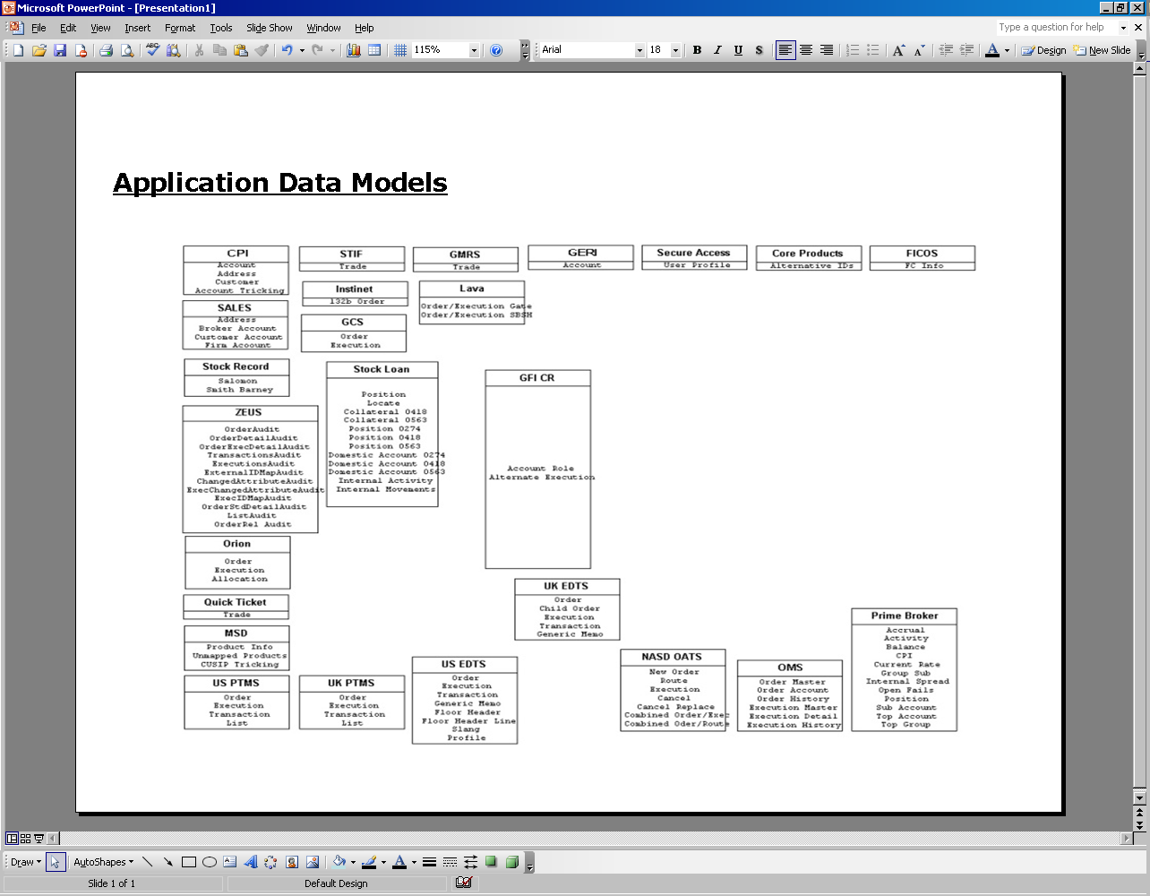

### Archival

* Each feed data on daily basis will be received from MSDB for archival purpose into mainframe through SFTP.
* Each record is pipe delimited data, will have same sequence as MSDB table column sequence. Length of each record will vary with other. And will be converted to fixed length record based pipe delimited.
* Converted fixed length record will be written to archival files. Every fixed length record also has pipe delimiter, to support the retrieval table loading in MSDB.

### Retrieval

* User request data for a specific feed system though NCAW CICS transaction. Each request is updated in database tables.
* New request from database is written to request file, processing.
* Based on the feed in the request, specific feed retrieval process will be initiated for data extraction from archival files.
* To support two file lengths for one feed in retrieval, two different DD names to be coded in program, and allocate them dynamically, EX: PROD feed retrieval
* Extracted data is FTPed to MSDB for loading in retrieval table, user can access from these tables online

### Component Architecture – Archival







## Component Architecture – Retrieval





In addition to the existing feeds we have created archival and retrieval setup for processing the below feeds from Pershing, Broadridge and MSSB.

* **Pershing**

**Overview**

In eliminating the dependency on MSSB Joint Venture for CITI Retained Wealth Management Businesses (CPB, IPB, and PWM), CITI came up with a shared platform to deliver Brokerage and Investments capabilities. The new platform will enable traditional brokerage business and support the new CPWM Registered Independent Advisor business operating model and new product offerings.

During Aug-Nov 2009, CITI evaluated multiple vendor platforms in partnership with business stakeholders and Deloitte Consulting and selected **Pershing** as a provider for both Brokerage and Investments capabilities:

* Brokerage platform evaluation encompassed Pershing, NFSI, and Broad ridge.
* Investments platform evaluation encompassed Pershing (Folio Dynamics), NFSI (EnvestNet), Broadridge, GTS’s Open Wealth, Charles River, and SEI.
* Findings were documented and socialized.

CITI decided on a “Fully Disclosed” model with a full convert away from CITI and MSSB to the new platform.

So, Pershing will be sending the retail data and we will continue to receive non-retail data from the same source as exists today.

Compliance requires a daily feed from pershing of order, trade, position, account and other reference data to Citi in a format acceptable to Citi IT for inclusion in the overnight batch processing in order to generate surveillance exceptions for compliance review on a T+1 basis.

In order to have history of the PERSHING-TO-CITI files, archival process is created for the following files

Files for archiving process

******************************

PTC-317 Trade File 1 - EOD consolidate

PTC-318 Trade File 2 - Modified Trades

PTC-319 Trade File 3 - Same Day Cancel

PTC-706 FT70-Firm Trading Activity Summary

PTC-707 FT90-Firm Trading Cumulative

PTC-327 Account - Customer Account Information

PTC-297 Position

PTC-722 OELG - Orders and Executions Log

### PTC317-Trades EOD consolidate

The Trades file (TRDE/TRDS) is created out of the Purchase & Sale (P&S) system, and is a result of trades that have been entered and executed through the various Pershing online order systems (for instance, the Institutional Operations Processing System (IOPS), Advanced Trade Order Management System (ATOMS), and the Bond Order Entry System (BOES). The Trades file contains all data that is pertinent to a trade, including customer and security information, as well as all monies and dates relevant to the trade. The data is offered on a trade date (file name is TRDSHDR) and a settlement date (file name is *TRSHDR) basis.

Approach: Data is segregated as CURR and ASOF files based on the TRADE DATE then archived on daily basis

Then send it to CDW with delimiters. WORM file would be created using 30 days accumulated CURR data file

Using monthly job.

### PTC318- Modified Trades

PTC318 contains the intraday modified trades.

Approach: Data is completely archived on daily basis then send it to CDW with delimiters. WORM file would be created using 30 days accumulated data file using monthly job.

### PTC319-Same Day Cancel Trades

PTC319 contains the intraday cancel trades.

Approach: Data is completely archived on daily basis then send it to CDW with delimiters. WORM file would be created using 30 days accumulated data file using monthly job.

### PTC706-Firm Trading Activity Summary (FT70)

The Firm Trading Activity Summary (FT70) file contains a recap of the prior day's trading activity for each security in each account, showing sales credits and calculating retained Profit and Loss (P&L) after sales credits are given up. Opening position (close from prior day) is shown, followed by all activity that took place in each security in the account and the final closing position for each security. This is a trade date data file with daily and month-to-date P&L information.

Approach: Data is completely archived on daily basis based on the DATE-OF-DATA then send it to CDW with

delimiters if it matches to the current Business date. WORM file would be created using 30 days accumulated

data file using monthly job.

### PTC707-Firm Trading Cumulative (FT90)

The Firm Trading FT90 Data file is created on a nightly basis. The "A" Record contains a month-to-date recap of all activity in the trading account, organized by CUSIP. Included in this file are trades, journal entries, interest (paid/received), dividends (paid/received), and all other cash and security transactions. This file also shows the IP number and customer account or contra broker.

Approach: Data is completely archived on daily basis based on the DATE-OF-DATA then send it to CDW with delimiters if it matches to the current Business date. . WORM file would be created using 30 days accumulated data file using monthly job.

### PTC327-Customer Account Information

All the records in the Customer Account Information file (ACCT and ACCF) are created from the Name and Address database, which is updated on a nightly basis. You can customize the data you receive in this file by selecting any or all of the categories as defined in the layout. Categories include Main Account, Account Holder/Participant, Custom Data Fields and PONA Supplemental, Cash Management Account, COD Account Settlement, Retirement Account, and Beneficiary Information

Approach: Data is completely archived on 1st business day of every month then the Delta file will be

Created from 2nd business day to till end of the month data based on OCCURRENCE NUMBER and CHANGE DATE of a particular account then send it to CDW with delimiters. WORM file would be created using 30 days accumulated data file using monthly job so that the month end file captures all the changes pertaining to single account.

### PTC297-POSITIONS

The Global Customer Position file is created after the close of business each day. The file reflects all account positions

Within your office range. Records can be passed to your firm on an update or refresh basis and include security descriptions. Positions file will have the positions data for the corresponding accounts on a particular business day

Approach: Data is completely archived on 1st business day of every month then the Delta file will be

Created from 2nd day to till end of the month data based on ACITIVITY DATE then send it to CDW with delimiters

On daily basis. WORM file would be created using 30 days accumulated data file using monthly job

so that the month end File captures all the positions pertaining to single account.

### PTC722-Orders and Executions Log (OELG)

The ORDER/EXECUTION LOG for BOOKS AND RECORDS file (OELG) is created from books and records

Repository, which is updated on a night basis. The file primarily focuses on order/execution data requirements

for books and records processing. It includes information on order changes, order routing, and rules engines as well

as order execution.

* **Broadridge**

**Overview**

Currently, the CGMI broker dealer operates under two different legacy infrastructures which creates operational and technical overhead and has implications for keeping both infrastructures up to date with the latest regulatory requirements. The scope of this project is limited to moving CGMI to one single platform using the Broadridge back-office infrastructure. At present, the project is gathering high-level business requirements to ensure that there is no loss of functionality when the migration occurs.

The introduction of Broadridge as the clearing platform will require new account numbers for the average price and error accounts. These account numbers must be reflected accurately in the Firms account databases that are maintained and utilized in the Compliance Data Warehouse, including those databases built within Broadridge. Currently, feeds from the account databases are received in MANTAS as a referential source and within CDW as a source for conducting additional research and analysis. Additionally, Compliance will require a new source of data for this business into the Compliance Data Warehouse (CDW).

New archival process should be set up for Broad ridge TML trades, Positions and Balances files and send the daily load files to MSDW through SFTP.

Files for Archival process

TML TRADES

POSITIONS

BALANCES

Approach: This will be almost same for all the following feeds. Broadridge sends the daily feed file which will be pipe delimited and sent for MSDW table loading. Data gets accumulated on a daily basis for a month and the corresponding monthly files will be archived in mainframe for future reference.

### TML Trades

Daily Feed of all trade data from Broadridge

Approach: Broadridge sends the daily feed file which will be pipe delimited and sent for MSDW table loading.

Data is getting accumulated on daily basis for a month and the corresponding monthly files being archived

in mainframe for future reference.

### Positions

Daily Feed of all positions data for the MSSB accounts.

Approach: Broadridge sends the daily feed file which will be pipe delimited and sent for MSDW table loading.

Data is getting accumulated on daily basis for a month and the corresponding monthly files being archived

in mainframe for future reference.

### Balances

Daily Feed of all Balances data for MSSB accounts.

Approach: Broadridge sends the daily feed file which will be pipe delimited and sent for MSDW table loading.

Data is getting accumulated on daily basis for a month and the corresponding monthly files being archived

in mainframe for future reference.

### BR MSDXREF

Security cross reference file for Broad ridge.

Approach: Data Approach: Broad ridge sends updated xref file on daily basis which will be pipe delimited and sent for MSDW table loading. Broad ridge xref history is maintained for any changes against the daily feed file.

* **MSSB**

**Overview**

Morgan Stanley Smith Barney (MSSB) is transitioning its brokerage support systems from a grouping of several Legacy Smith Barney (LSB) systems to a more consolidated approach within its own platforms. Key to this process is ensuring that all systems, electronic, mechanical or human, remain fully functional in their role to supervise and monitor personal brokerage accounts for Citi employees and their related persons (collectively, Covered Employees), while meeting regulatory or legislative requirements. The migration of the LSB accounts to a consolidated MSSB platform is scheduled to occur in three phases, with the first phase occurring in February 2012 followed by the second phase in May 2012 and a final phase in July 2012. At the conclusion of the migration, it is projected that approximately 70,000 + LSB accounts associated with a Covered Employee will reside on the MSSB platform.

For efficiency and continuity purposes, Compliance prefers to continue generating IBSG surveillance reports and ad hoc tools internally with the inclusion of data received from MSSB on a daily basis. This document outlines IBSG business requirements in regards to the integration of account, position and trade data expected to be received from MSSB on a daily basis for the purpose of monitoring employees and their related persons in accordance with policy and regulatory requirements.

Compliance needs account, position and trade data for designated covered employees and their related persons’ accounts held at MSSB fed into the existing surveillance reports/processes. This includes updating/building any queries used for ad hoc reviews or responding to regulatory requests/inquiries. The complete list of surveillances in-scope is located in Section 3.0 “Current Processes.”

New archival process should be set up for MSSB Trades, Account, MSDXREF and Position feeds and send the daily

load files to MSDW through Sftp.

Files for Archival process

1. Name Address(Account data)
2. Transaction (Trades)
3. Position
4. MSDXREF

### Name & Address (Account data)

Daily Feed of all account descriptor data from MSSB.

Approach: MSSB sends the daily feed file which will be pipe delimited and merged with the OARS feed file to populate the GEID for all these MSSB accounts and the final file will be sent for MSDW table loading. Data is getting accumulated on daily basis for a month and the corresponding monthly files being archived in mainframe for future reference.

### Transaction (Trades)

Daily Feed of all transactional activity for the MSSB accounts.

Approach: MSSB sends the daily feed file which will be pipe delimited and sent for MSDW table loading.

Data is getting accumulated on daily basis for a month and the corresponding monthly files being archived

in mainframe for future reference.

### Positions

Daily Feed of all positions data for the MSSB accounts.

Approach: MSSB sends the daily feed file which will be pipe delimited and sent for MSDW table loading.

Data is getting accumulated on daily basis for a month and the corresponding monthly files being archived

in mainframe for future reference.

### MSDXREF

Security cross reference files with the matching SB Cusip.

Approach: Data Approach: MSSB sends updated xref file on daily basis file which will be pipe delimited and sent for MSDW table loading. Data is getting accumulated on daily basis for a month and the corresponding monthly files being archived in mainframe for future reference

## Testing procedure for Archival Jobs

* Test files are provided by Pershing team, as these are the major file changes
* Execute the test jobs with Pershing test files then create the output files. And subsequent jobs should be executed with newly created output files
* Data retrieved is send to CDW using test FTP jobs, and gets loaded for user verification.

**5758 – Compliance research front running**

**Business Overview**

Compliance research front running application is to generate regulatory reports for the business users to review the reports every day as per the regulatory requirement

## Application Overview

As part of Compliance research front running application, following are the reports generated

* RD SALES
* DAILY TRADE REPORT – Preclear P&L and SSN
* WATCH LIST REPORT
* RESEARCH FRONTRUNNING 5DAY MGD/NONMGD REPORT
* RESEARCH CHANGE EMPLOYEE TRADING EXCEPTION REPORT
* RESEARCH FRONTRUNNING REPORT(PROPRIETARY ACCOUNTSREPORT)
* RESEARCH FRONTRUNNING CIS 5DAY MGD/NONMGD REPORT
* AUSTRALIAN - RESEARCH FRONTRUNNING REPORT
* LONDON - RESEARCH FRONTRUNNING REPORT
* JAPAN - RESEARCH FRONTRUNNING REPORT
* HONG KONG - RESEARCH FRONTRUNNING REPORT

## Detailed Report Description

## WATCH LIST REPORT

**What is’ WATCH LIST’?**

List of securities singled out for special surveillance by a brokerage firm or an exchange or other self-regulatory organization to spot irregularities. Firms on the watch list may be takeover candidates, companies about to issue new securities, or others that seem to have attracted an unusually heavy volume of trading activity.

**Report Abstract**

1. Using the trade files created in the ‘ZLGD820N’, match with watch list securities list created from ZGCD117N , create trade file with only trades related to watch list securities
2. Watch list trades are segregated as USA and International accounts
3. For both USA and International accounts, based on the employee type and Report type, trades are segregated and reported accordingly

## Restricted securities violations Report

**Job : ZGCD517N**

**AMMO ID : NGCD517B0**

**Report Abstract**

1. NCCB542 program creates the above exception reports from the input trade records. The various trade exception files are sorted/merged in the different sequence for each of the reports produced by this program.
2. Trade files created from the job ZCCD517N are filtered in program NCCB52B to have exception 3 records and then individual compliance exception files having matched restrictions sorted in firm, security description, branch, fc, account number, trade id, exception order are created and used as input trade file. These Records are checked in the CUSIP file to obtain the symbol.

## DAILY OVER THE WALL EMPLOYEE TRADE REPORT

**What is ‘Over the Wall’ ?**

A situation where an employee in the research department of an investment bank - usually a research analyst - is brought over to work for the underwriting department in order to focus on a particular company. The purpose of such a transfer is to add a knowledgeable opinion to the underwriting process, thereby adding value to it.

In financial firms, the separation between the investment analyst and the underwriting departments is described as the "wall", as in the Great Wall of China. The division exists as an ethical boundary to guard against the exchange of insider information between the two departments.

Once the underwriting process is complete, the research employee who has been brought over "the wall" is not allowed to comment on any information learned in the underwriting process until it has become public knowledge

Also known as "brought over the Chinese Wall".

**Job : ZGCD246N**

**AMMO ID: NGCD246A0**

**Report Abstract**

This is basically Employee Daily trade reports for selected SSN created from the following files

a) Surveillance.

b) Daily trade

c) HR report

d) SMQSPMST

## Research Front-Running Reports:

**Excerpt on Front-Running:**

Front running is the illegal practice of a stock broker executing orders on a security for its own account while taking advantage of advance knowledge of pending orders from its customers. When orders previously submitted by its customers will predictably affect the price of the security, purchasing first for its own account gives the broker an unfair advantage, since it can expect to close out its position at a profit based on the new price level. Front running may involve either buying (where the broker buys for their account, before filling customer buy orders that drive up the price) or selling (where the broker sells for its own account, before filling customer sell orders that drive down the price).

Allegations of front running occasionally arise in stock and commodity exchanges, in scandals concerning floor brokers and exchange specialists.

For example, suppose a broker receives an order from a customer to buy a large block of 400,000 shares of some stock, but before placing the order for the customer the broker buys 20,000 shares of the same stock for his own account at $100 per share, then afterward places the customer's order for 400,000 shares, driving the price up to $102 per share and allowing the broker to immediately sell his shares for, say, $101.75, generating a significant profit of $35,000 in just a short time. This $35,000 is likely to be just a part of the additional cost to the customer's purchase caused by the broker's self-dealing.

This example uses unusually large numbers to get the point across. In practice, computer trading splits up large orders into many smaller ones, making front-running more difficult to detect. Moreover, the U.S. Securities and Exchange Commission's 2001 change to pricing stock in pennies rather than fractions of no less than 1/8 of a dollar facilitated front running by reducing the extra amount that must be offered to step in front of other orders.

By front-running, the broker has put his or her own financial interest above (or in front of) the customer's interest and is thus committing fraud. In the U.S. he or she might also be breaking laws on market manipulation or insider trading.

## Daily Trade Report:

Daily trade report lists the trades pre-selected for pre-clear P&L’s, special SSN lists, GSS employees etc. The report contains the information related to the employee name, emp code, relation code, DEPT name & number, SSN number, Trade date, Settlement date, CUSIP, Security symbol, security description and information about shares.

The main job which triggers the daily trade report

**Job : ZGCD681N**

**AMMO ID: NGCD681A0**

**Report Abstract**

Job - ZGCD681N creates different kind of reports related to daily trade. They are

Daily Trade report

Daily Trade report Supplement

Daily Trade report – Citi International Employees

Daily Trade report – Citi International Employees Supplement

Daily Trade report – Citi Analytics Employees

Daily Trade report – Citi Analytics Employees Supplement

Daily Trade report – Public side Managers

Daily Trade report – Public side Managers Supplement

Daily Trade report – Municipal Securities

Daily Trade report – Municipal Securities Supplement

All these reports are getting generated using the program NCCB563 in the proc – PGCD681N.The Main driver file data for segregation of these reports is stored in BPS.CARDLIB and the trade files which are getting created in the job ZLGD820N.

**33382 - IB Surveillance**

**Business Overview**

IB surveillance system is trade enquiry system, where the user could log request online, and batch jobs extracts actual trade data and send the report to the user requested.

**Application Overview**

Trade enquiries placed online to retrieve data from history files and same is processed on nightly batch, and report will be send to requested user.

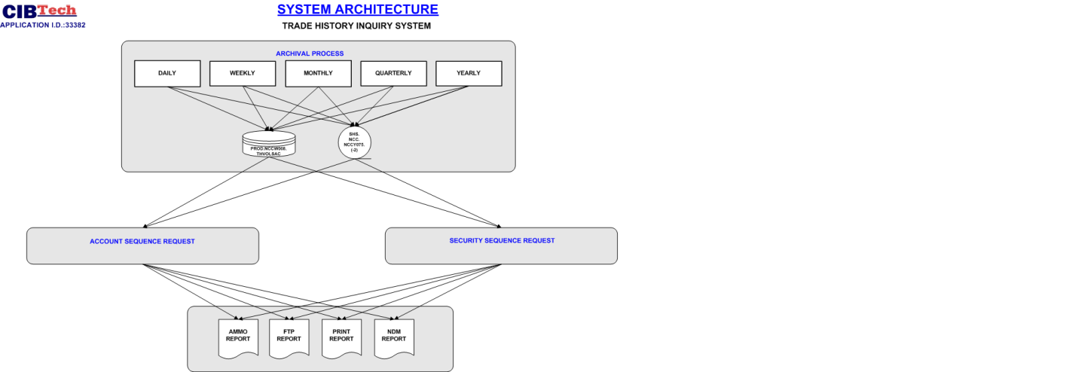



## Component Architecture

